Here's a clean line diagram of the multi-agent system flow, from client brief through to the Revit model:This traces the same architecture from the plan document as a single top-down line diagram: brief → Supervisor → the six discipline agents (grouped in their own tier) → Reviewer/QA → the human approval gate → Execution agent → Revit model, with the revision loop noted at the bottom rather than drawn as a crossing arrow.
If you'd like, I can do a second one just for the org chart (people/roles) in this same clean style, or a more detailed version showing the Handoff/Concurrent routing between specific worker agents.

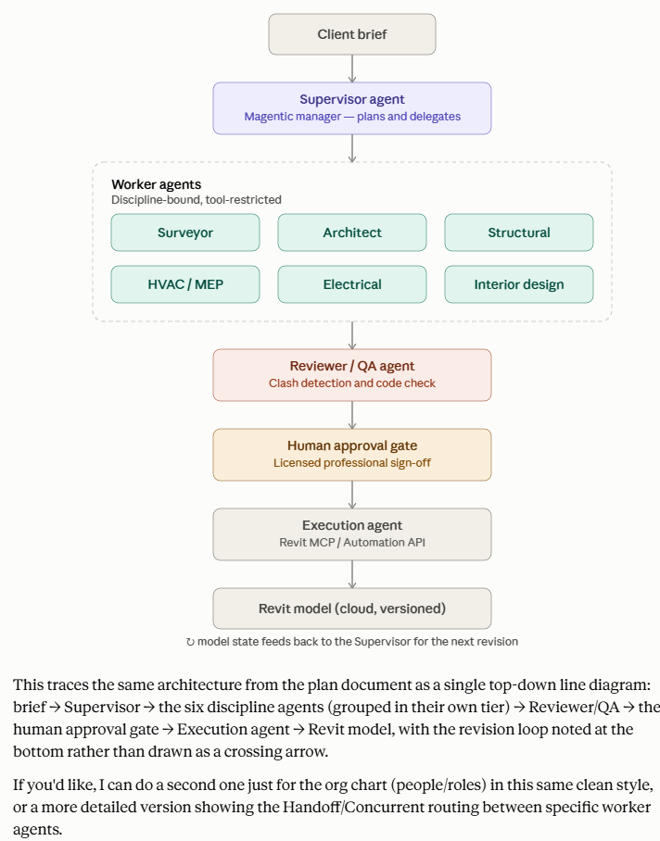
Two things drove the redesign, and both are reflected throughout the document:
1. Saudi regulatory reality — the licensing path is now concrete: MISA investment license → MOCI Commercial Registration → SCE accreditation (both the firm and every practicing engineer) → MOMRAH/Balady engineering office license → ZATCA/GOSI/Qiwa → SDAIA controller registration (PDPL). Worth flagging clearly: the foreign-ownership rules for engineering consultancies have shifted meaningfully in recent years (moving toward 100% foreign ownership for most activities), so that specific point needs a final check with local counsel before you file anything — it's the fastest-moving part of what I found.
2. Revit is local, not cloud — this actually simplifies your execution layer. Instead of the Autodesk cloud Automation API from the original design, the Execution agent now talks to a Revit add-in exposing a local MCP server over localhost/LAN. The building model itself never has to leave the machine — only instructions and results cross into the orchestration layer, which is a genuine advantage for PDPL compliance, not just a technical workaround.
One more thing worth knowing: Microsoft's Saudi Arabia East Azure region goes GA in November 2026 — that's essentially your natural migration point for in-Kingdom AI model hosting once it's live, so the plan treats "on-prem now" as a deliberate bridge, not a permanent state.
Want the matching line diagram next — showing the local-network boundary around Revit and the compliance zone the way I did for the previous architecture?

